**Meeting Minutes – Iowa DOT September 07th, 2016**

**Guide to Data and Information Sharing Workflows across the Life Cycle of Transportation Assets**

Date: 09/07/16

Attendees: Dr. Jeong, Lee Shepard, Tuyen Le

Venue: Iowa DoT

1. Software used by construction office:

- Bentley viewer: used to view cad/microstation files from designers if necessary.

- FieldManager: used by officers in RCE for administrating the project. Field manager can read data in a database of contracts. Each contracts is stored in one table which have the following attributes: contract id, project id, contract description, comments, closed, access (working, readonly-this means project is already done), prime contractor, awarded construction amount, current construction amount, location, route, %complete, managing office, construction started date, closed to traffic date, open to traffic date. This is more like an accounting software to manage the payments to the contractor.

- FieldBook: looks similar to field manager, but specifically used by inspector to record and track construction activities through daily inspect report.

- Filed manager and FieldBook are InfoTech products

- Iowa dot is moving to AsshtoWare Project which is an integrated solution. Now implemented for preconstruction, next will be the construction module and then material module.

- DocExpress is to store contract related documents where the contractor submits their documents such as change order, schedule, etc. This s a website-based database. Other documents from the office of contracts such as specifications, plans, drawings can also found in this website. Certification and documentations of payment items are stored in DocExpress. Some of project information such as contracted schedule in DocExpress will be manually extracted by RCE and typed into the FieldManager. DocExpress and FieldManager are used conjunction each other during the construction phase, there are mostly not data exchange between these two systems. Some final documentations generated in FieldManager will stored in DocExpress. DocExpress is temporary storage of contract documents. To download a file from here, an email with download link will be sent to the user.

- ProjectWise is not used by majority of RCE.

- ERMS is final permanent storage place to store project related docs. ERMS staff manually transferring a portion of DocExpress (required docs) to ERMS. This process is time consuming, since DocExpress does support API for automatically downloading files from DocExpress.

2. Contract databases: There are 14 CRE and each of these has a separate databases of contracts that they are managing. these databases are archived on a local server that anyone with access permit can access to. These databases are not merged together.

3. Data exchange between Office of contracts TO Construction office: received data are saved in comma separated values (CSV). Data includes contract id, contractor, bid items, etc. These data is automatically brought in by the managing office (CRE). One contract may involve multiple contracts who perform some of the bid items.

4. Managing office TO inspector. Contract manager in RCE exports a portion of data in field manager to field book to each of the inspectors. RCE managing the project but not micro-managing the project. Inspectors make payment, inspect construction activities, collecting certifications, verify quantity and quality. RCE managing all the projects in the district, signs paperwork that require engineering signatures based on recommendation from the inspector. In FieldBook program, inspector creates IDR and put in data and attachment (such as pictures) recorded including payment, then he post it.

5. Schedule and other disputes with contractor. if there is a significant difference between scheduled and actual, RCE and contractor negotiate and determine if a penalty must be made. If two sides fail to find a common point, legal process would be considered.

6. Contract related documents including ones submitted by contractor such as schedule, change orders, and letting documents such as plans, specifications are stored in DocExpress. These data are stored in pdf format. Office of construction would love to have 3D pdf. The office of contracts can also provide e files, excel spreadsheets, digital drawing to the contractor. Digital data are provides is on project by project basic, not all projects. Currently, Iowa dot not require contractors to submit their digital drawings.

7. As-built drawings stored in ERMS not in DocExpress. If project performed by in-house inspectors, as-built drawings are prepared by the inspector. As-built drawings are based 2D plans marked up with read-lines. Some of the information in as-built drawings can be found in daily reports, but geometry info are not recorded in daily reports.

8. Maintenance and construction. There is no link between these two department. Maintenance does not require any data to be handed over form construction. If they need, they will go through erms to find information that they need.

9. Construction inspector are just now starting using esri collector app to collect asset information from construction phase by a handful of inspectors. almost 99% of the data points are collected by the maintenance staff. Collecting asset data benefit to design and maintenance but does not benefit the payment related stuffs. Using collector apps during construction, the work performance of construction projects are tagged with geospatial information and can be visualized. Shawn may moving from ArcGis to Oracle database, because oracle data is easier fro query. Construction is starting to used esri dashboard to keep track construction operations.

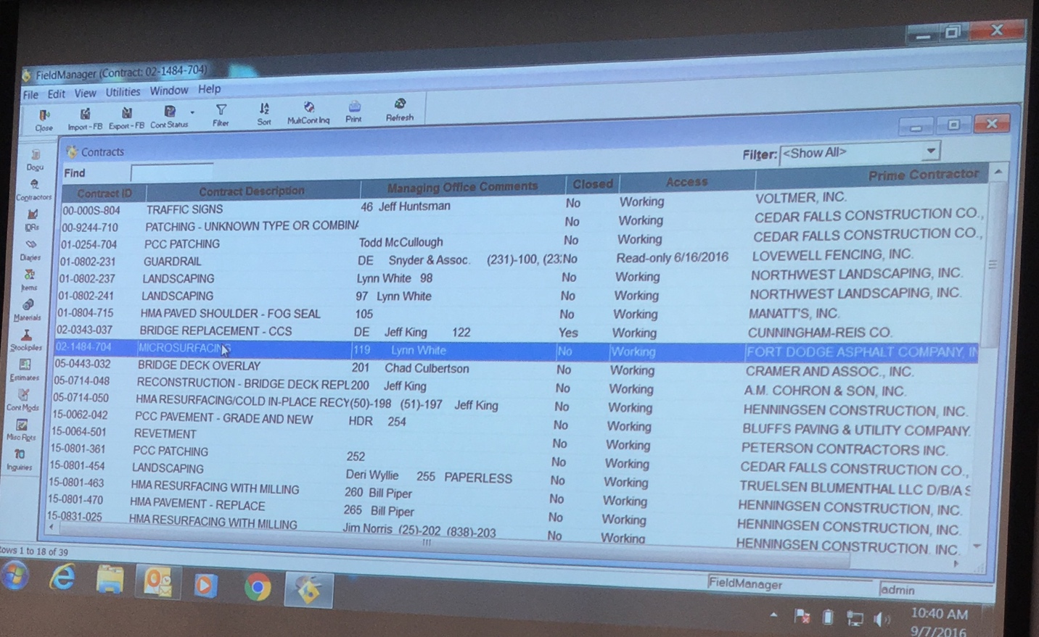

Figure1. FieldManager shot 1

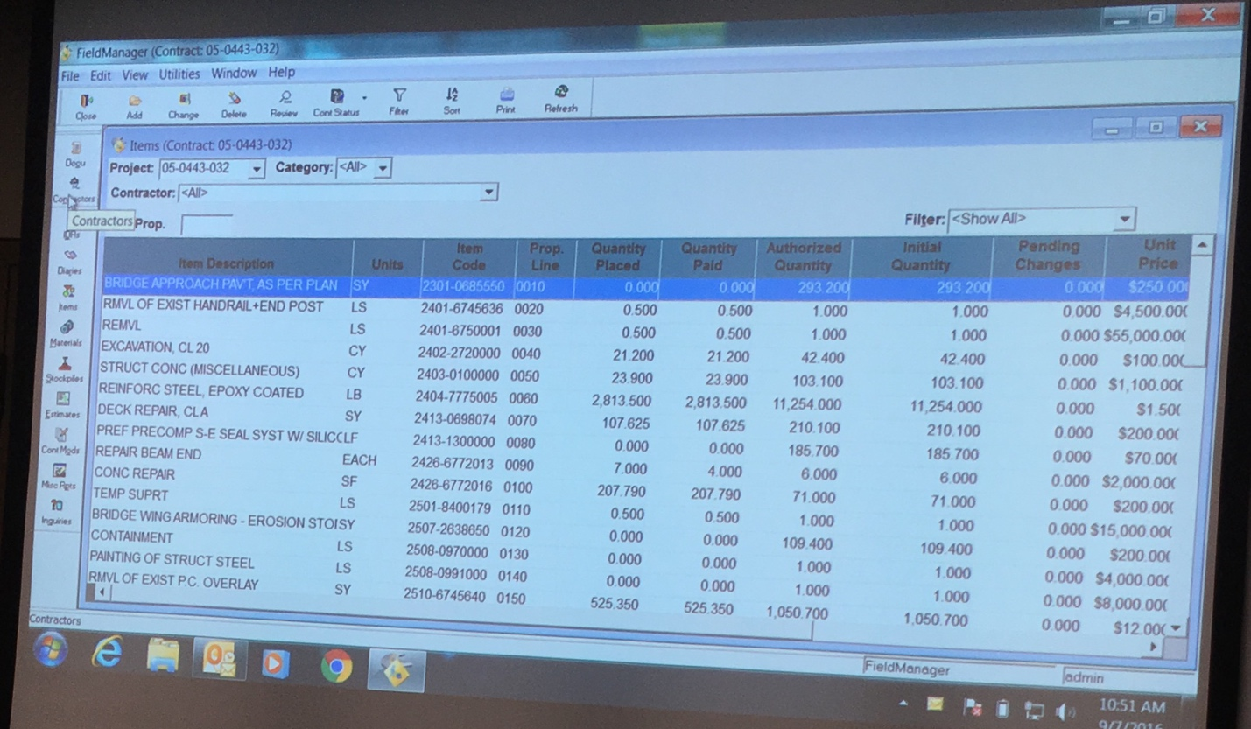

Figure2. FieldManager shot 2

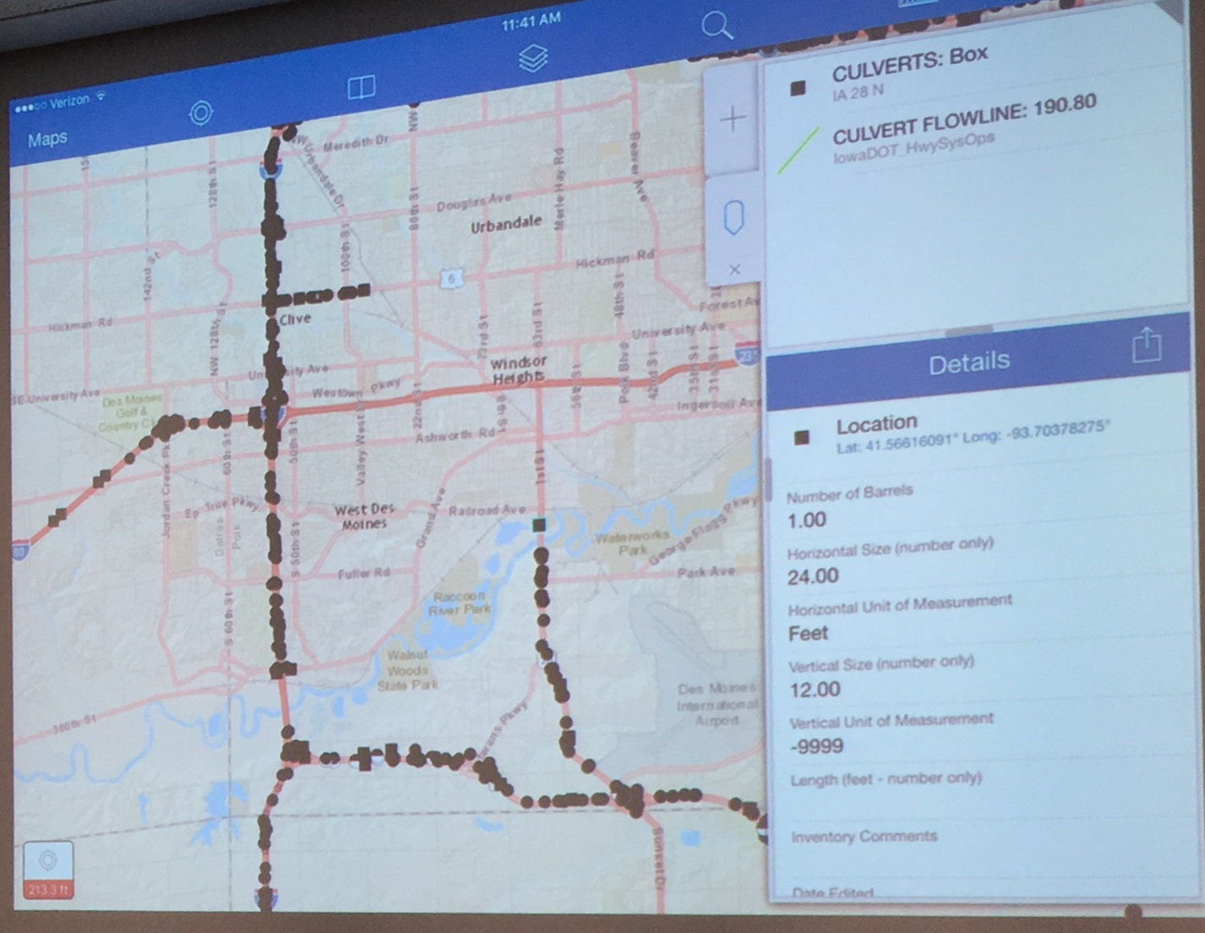

Figure 3. ersi Collector app